LAB 10
Task 1:
#include <iostream>
using namespace std;

class LinearHash
{
public:
int table[7];

LinearHash()
{
for(int i=0;i<7;i++)
table[i] = -1;
}

void insertKey(int k)
{
int h = k % 7;
cout << "\nInserting key " << k << " -> Initial index: " << h;

int start = h;
bool firstCollisionReported = false;

while(table[h] != -1)
{
if(!firstCollisionReported)
{
cout << " (Collision at index " << h << ")";
firstCollisionReported = true;
}
h = (h + 1) % 7;
}

cout << " → Placed at index " << h << endl;
table[h] = k;
}

void display()
{
cout << "\nFinal Linear Probing Table:\n";
for(int i=0; i<7; i++)
cout << "[" << i << "]: " << table[i] << endl;
}
};

class ChainHash
{
public:
struct Node
{
int v;
Node* next;
};

Node* table[7];

ChainHash()
{
for(int i=0;i<7;i++)
table[i] = NULL;
}

void insertKey(int k)
{
int h = k % 7;
Node* n = new Node;
n->v = k;
n->next = table[h];
table[h] = n;

cout << "Inserted key " << k << " at chain index " << h << endl;
}

void display()
{
cout << "\nSeparate Chaining Table Structure:\n";
for(int i=0; i<7; i++)
{
cout << "[" << i << "]: ";
Node* t = table[i];
while(t)
{
cout << t->v << " -> ";
t = t->next;
}
cout << "NULL\n";
}
}
};

int main()
{
int keys[6] = {76, 93, 40, 47, 10, 55};

cout << "===== LINEAR PROBING INSERTIONS =====\n";
LinearHash L;
for(int i=0;i<6;i++)
L.insertKey(keys[i]);
L.display();

cout << "\n===== SEPARATE CHAINING INSERTIONS =====\n";
ChainHash C;
for(int i=0;i<6;i++)
C.insertKey(keys[i]);
C.display();

cout << "\nFor Separate Chaining:\n";
cout << "Key 55 -> hash index = 55 % 7 = " << (55 % 7) << endl;
cout << "It will be inserted at the head of the chain at index " << (55 % 7) << ".\n";

return 0;
}

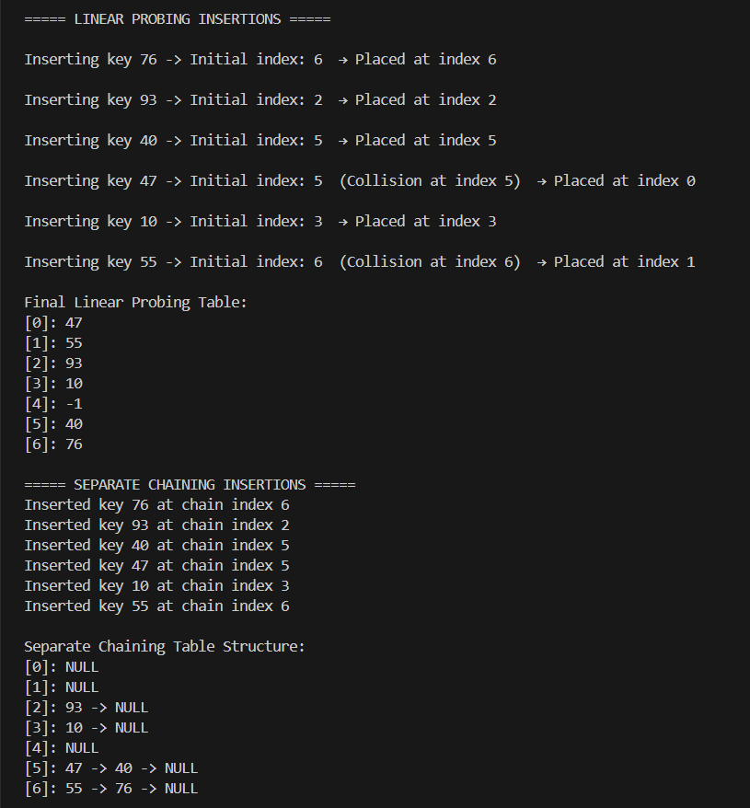
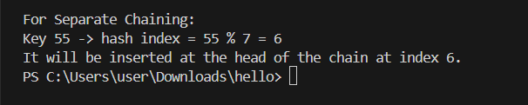

Task 2:
#include <iostream>
using namespace std;

class HashTable
{
public:
int size;
int elements;

HashTable(int s, int e)
{
size = s;
elements = e;
}

double loadFactor()
{
return (double)elements / size;
}
};

class Rehashing
{
public:
int newSize(int old)
{
int start = old * 2;
for(int i = start; ; i++)
{
bool prime = true;
for(int j = 2; j * j <= i; j++)
{
if(i % j == 0)
{
prime = false;
break;
}
}
if(prime)
return i;
}
}
};

int main()
{
HashTable H(100, 75);

double lf = H.loadFactor();
cout << "Load Factor = elements / size = "
<< H.elements << " / " << H.size << " = " << lf << endl;

if(lf >= 0.75)
cout << "Rehashing is required (load factor reached 0.75)." << endl;
else
cout << "Rehashing is NOT required yet." << endl;

Rehashing R;
int newSize = R.newSize(H.size);
cout << "\nSuggested new table size (next prime after doubling): "
<< newSize << endl;

cout << "\nSteps in Rehashing:\n";
cout << "1. Create a new empty hash table of size " << newSize << ".\n";
cout << "2. Recompute hash values for all existing elements and insert them into the new table.\n";
cout << "3. Replace the old hash table with the new one.\n";

return 0;
}

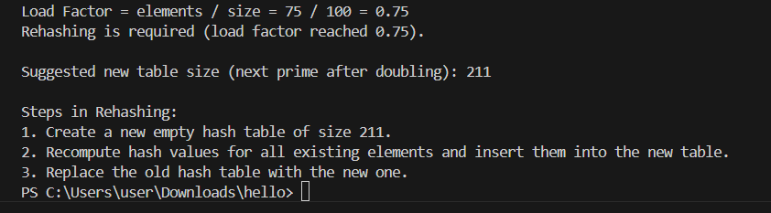

Task 3:
#include <iostream>
using namespace std;

class BruteForce
{
public:
int search(string T, string P)
{
int n = T.size();
int m = P.size();

for(int i = 0; i <= n - m; i++)
{
int j = 0;
while(j < m && T[i + j] == P[j])
j++;
if(j == m)
return i;
}
return -1;
}
};

class BoyerMoore
{
public:
void buildBadChar(string P, int last[])
{
for(int i = 0; i < 256; i++)
last[i] = -1;

for(int i = 0; i < P.size(); i++)
last[P[i]] = i;
}

int search(string T, string P)
{
int last[256];
buildBadChar(P, last);

int n = T.size();
int m = P.size();
int i = 0;

while(i <= n - m)
{
int j = m - 1;

while(j >= 0 && P[j] == T[i + j])
j--;

if(j < 0)
return i;

char bad = T[i + j];
int shift = j - last[bad];
if(shift < 1) shift = 1;

i += shift;
}
return -1;
}
};

int main()
{
string T = "GCAATGCCCTATGTGACC";
string P = "TATGT";

BruteForce BF;
BoyerMoore BM;

cout << "Brute Force Match Index: " << BF.search(T,P) << endl;
cout << "Boyer-Moore Match Index: " << BM.search(T,P) << endl;

return 0;
}

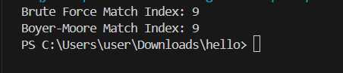

Task 4:
#include <iostream>
using namespace std;

class KMP
{
public:
void buildLPS(const string &P, int lps[])
{
int n = P.size();
lps[0] = 0;

int len = 0;
int i = 1;

while (i < n)
{
if (P[i] == P[len])
{
len++;
lps[i] = len;
i++;
}
else
{
if (len != 0)
len = lps[len - 1];
else
{
lps[i] = 0;
i++;
}
}
}
}
};

int main()
{
string P = "ABABA";
int lps[5];

KMP k;
k.buildLPS(P, lps);

cout << "Pattern: " << P << endl;
cout << "LPS Array: ";
for (int i = 0; i < P.size(); i++)
cout << lps[i] << " ";
cout << endl << endl;

cout << "1. Meaning of LPS[4]:" << endl;
cout << " LPS[4] = " << lps[4] << " means the substring ABABA has a prefix and suffix of length 3 (ABA)." << endl;
cout << "2. Mismatch at P[4]:" << endl;
cout << " LPS value of previous index P[3] is " << lps[3] << "." << endl;
cout << " After mismatch, KMP restarts comparison from pattern index " << lps[3] << "." << endl;

return 0;
}

